|  |
| --- |
| **HERITAGE AND EVENTS COMMITTEE**  **AGENDA PACK**  **13 NOVEMBER 2024** |

Thetford Town Council, The Carnegie, Cage Lane, Thetford, IP24 2DS

Tel: 01842 754247

**THETFORD TOWN COUNCIL**

**HERITAGE AND EVENTS COMMITTEE**

Date: **Wednesday 13 November 2024** Time: **6:00 pm**

Place: **Guildhall Council Chamber, The Guildhall, Market Place, IP24 2DT**

**Members are hereby summoned to attend the above meeting to transact the following business. Members are respectfully reminded that each item on the agenda should be carefully examined.**

**COMMITTEE MEMBERSHIP:**

A. Blackbourn (Chair), D. Jefferson (Vice Chair), M. Brindle, M. MacDonald, V. Peters, V. Ross-Smith,

M. Stirrup, S. Wright, T. Jermy, C. Barreto.

**FOR INFORMATION:**

D. Blackbourn, I. Evans, C. Harvey, T. Land, H. McCambridge, A. Mitchell, S. Terry, R. Wood.



**Town Clerk**

**8 November 2024**

**AGENDA**

|  |  |
| --- | --- |
| **396/24** | **Apologies for Absence**  To receiveand approve apologies for absence. |
| **397/24** | **Minutes Heritage and Events Committee**  To confirm the minutes of the Heritage & Events Committee meeting held on 18 September 2024 as a true record and be signed by the Committee Chair.  Decision required: To agree the minutes of the last meeting.  Lead: Chair. |
| **398/24** | **Declarations of any Disclosable Pecuniary Interests**  To receive any additional interest not already registered. |
| **399/24** | **Financial Report and Other Financial Information**  To receive and discuss the Financial Report for the period ended 30 September 2024 as well as other financial information.  Decision required: To note the Financial Report.  Lead: Deputy Town Clerk. |
| **400/24** | **Update on Mayoral and Civic Events**  To review and discuss a written delivered events and provide an update on those upcoming in the Mayoral / Civic calendar. To also note changes in the staffing of the Civic function.  Decision required: To note the update.  Lead: Committee Officer. |
| **401/24** | **Update on Town and Partnership Events 2024/25**  To receive a written update on delivered Town and Partnership Events since the last Committee meeting and to discuss future Town and Partnership Events planned.  Decision required: To note the update.  Lead: Committee Officer. |
| **402/24** | **Update on Educational Projects**  To receive a written update on delivered Educational Projects since the last Committee meeting and to discuss future Educational Projects planned.  Decision required: To note the update.  Lead: Committee Officer |
| **403/24** | **Programme of Events for the 2025/26 budget year**  To receive and discuss a proposed programme of events for inclusion in the Committee’s budget for 2025/26.  Decision required: To approve the programme of events.  Lead: Chair. |
| **404/24** | **VE and VJ Day 80th Anniversary 2025**  To review ideas and estimated costs to celebrate the 80th Anniversary of VE and VJ Day in 2025 as proposed in the working group entrusted with this task.  Decision required: To consider the proposals of the working group and to confirm a project plan.  Lead: Chair and Councillor Vic Peters. |
| **405/24** | **Thetford Community Festival**  To receive a verbal update on the planned Thetford Community Festival in 2025. To discuss what roles, if any, are proposed for the Town Council to undertake in supporting this event.  Decision required: To note the update and to identify possible roles that could be undertaken by the Town Council.  Lead: Councillor Carla Barreto. |
| **406/24** | **Review of the Venue Hire Charges, Concessions and Booking Terms and Conditions**  To review and discuss the proposed changes to the Venue Hire Charges for 2025/26. To also review proposed changes to the Booking Terms and Conditions for Venues.  Decision required: To approve the proposed Venue hire charges and Booking Terms and Conditions.  Leads: Chair and Committee Officer. |
| **407/24** | **Use of Guildhall facilities and Council staff time for In-House Community Groups**  To receive a report on the continued use of the Guildhall facilities for continuation of In-house Community Groups as well as the use of Council staff time.  Decision: To decide whether the Council continues to support these In-House Community Groups.  Lead: Chair |
| **408/24** | **Progress on Actions from Previous Meeting**  To review and update the action points brought forward from the previous Heritage and Events meeting.  Decision required: To review and update the action points.  Lead: Chair. |
| **409/24** | **Committee Officers Update**  To receive any update from the Committee Officer since the agenda for this meeting was issued.  Decision required: None.  Lead: Committee Officer. |

**A recording of the meeting can also be viewed on** [**https://bit.ly/ttceventsyoutube**](https://bit.ly/ttceventsyoutube)

**usually within 5 working days after the meeting has been held.**



**DRAFT**

**Agenda Item 397/24**

|  |  |
| --- | --- |
| Report To: | Heritage & Events Committee |
| Date of Meeting: | 13th November 2024 |
| Authorship: | Deputy Town Clerk |
| Subject: | Confirm the Minutes |

**To confirm the minutes of the Heritage & Events Committee meeting held on 18September 2024 as a true record and be signed by the Committee Chair.**

Present: Councillors: A. Blackbourn (Chair)

M. Brindle

D. Jefferson (Vice Chair)

M. MacDonald

V. Peters

V. Ross-Smith

C. Barreto

C. Harvey

T. Land

Officers: A. Yorke (Deputy Town Clerk)

D. Brooks (Committee Officer)

K. Robinson (Committee Clerk)

Members of Public: There were none.

**310/24** **Apologies for Absence**

Apologies were received from Councillors T. Jermy, M. Stirrup and S. Wright.

**311/24** **Minutes Heritage and Events Committee**

The minutes of the Heritage and Events Committee meeting held on the 21 August 2024 are a true record and signed by the Chairman.

**312/24** **Declarations of any Disclosable Pecuniary Interests**

There were none.

**313/24** **Update on Mayoral and Civic Events**

The Committee Officer provided the committee with a verbal summary of the upcoming and recent events within the town.

**Actions:**

1. Committee Officer to provide information to the Councillors regarding the process for the Remembrance Event; immediately.
2. Committee Officer to speak with RBL representatives regarding the correct positioning of the Mayor’s wreath on the front or back of the memorial in the Market Place; immediately.
3. Committee Officer to organise a mini walk-around with the Sword and Mace Bearer and Councillors before November’s Full Council meeting; immediately.

The update was noted.

**314/24** **Update on Town Events 2024/25**

The Committee Officer provided an update to the Committee on recent events An event schedule for 2024/25 will be discussed at November’s committee meeting.

**Action:** Suggested events schedule to be included on November 2024 agenda.

The update was noted.

**315/24 Preliminary Ideas to Celebrate VE and VJ Day 2025.**

The Committee discussed ideas to celebrate the 80th Anniversary of VE and VJ Day in 2025, including FEPOW (Far East Prisoners of War). It was felt that the two events had to be done differently and try to be as inclusive as possible for residents.

**Action:** Working Party and meeting to be arranged to be set up comprising Councillors V. Peters, M. MacDonald, C. Barreto and C. Harvey, plus the Heritage Officer; immediately.

**316/24** **Thetford Town Council Flag Policy**

The Committee discussed a new Flag Flying Policy.

**Proposed by Councillor C. Harvey and seconded by Councillor M. MacDonald.**

**RECOMMENDATION:** To adopt the new Flag Flying Policy and recommend to Full Council.

**Action:** To include recommended on Full Council agenda for October 2024; immediately.

**317/24** **Heritage Masterplan Next Steps**

The Committee discussed the next steps to be undertaken by the Committee to progress the next phase of the Heritage Masterplan. A Working Group comprising Councillors A. Blackbourn (Chair), M. Brindle and D. Jefferson has already been established.

**Proposed by Councillor V. Peters and seconded by Councillor M. MacDonald.**

**RECOMMENDATION:** To recommend the process, including a budget to Full Council for the appointment of a Bid Writer to commence in November 2024 to be approved by Full Council.

**Action:** Deputy Town Clerk to send an email to all Councillors inviting them to join the Working Group; immediately.

**318/24** **Financial Report and Other Financial Information**

The Committee discussed the Financial Report for the period ended 31 July 2024 as well as other financial information that was distributed in the Presentation Pack. The Deputy Town Clerk explained the ongoing project to transform the accounting records of the Council in relation to Civic and events function.

The Committee noted the Financial Report and approved the structure of the financial information presented.

**319/24** **Progress on Actions from Previous Meeting**

The Committee Officer gave a brief update and completed items were identified and noted.

Councillor V. Peters left the meeting at 19:22 hours.

**320/24** **Committee Officers Update**

There was none.

**321/24** **Exclusion of Press and Public**

The Committee resolved to exclude the press and public.

Councillor D. Jefferson left the meeting at 19:30 hours.

**322/24** **Confirmation of Eligibility to Free Hires and Concessions**

The Committee discussed a report on free hires and the granting of concessions to hirers.

**Proposed by Councillor C. Barreto and seconded by Councillor V. Ross-Smith.**

**RESOLVED:** To receive a report on current hire fees and concessions and to request a report on proposed fees and concessions.

**Actions:**

1. To review existing free hires; immediately.
2. To ensure that all free hires are considered and approved by this Committee; immediately.
3. To receive a report on a quarterly basis on all free hires that have been given during the quarterly period; immediately.
4. To review all hire charges for all venues. This will include comparative research with other hirers in the greater local area; immediately.
5. To make recommendations, including concessions, to this Committee at its November 2024 meeting for inclusion in the budget; immediately.

**323/24** **Review of a Cancelled Booking**

The Committee discussed a report on a cancelled booking.

**Proposed by Councillor M. MacDonald and seconded by Councillor C. Barreto.**

**RESOLVED:** To return the deposit to the affected hirer.

**Action:** To request that Officers provide Terms and Conditions for hirers regarding deposits, and that Officers adhere and enforce new terms and conditions for all hirers; immediately.

**The meeting closed at 19:50**

Chairman: A. Blackbourn



**Agenda Item 399/24**

|  |  |
| --- | --- |
| Report To: | Heritage & Events Committee |
| Date of Meeting: | 13th November 2024 |
| Authorship: | Deputy Town Clerk |
| Subject: | Financial Report and Other Financial Information |

**To receive and discuss the Financial Report for the period ended 30 September 2024 as well as other financial information.**

**Financial Reporting**

There is an ongoing project to transform the accounting records of the Council, particularly in respect of the Heritage and Events Committee because this Committee currently oversees mayoral, civic, commercial and community related activities. It also oversees the educational support provided to local schools.

Previously, the financial reports have not made this distinction and as a result, the Committee has not always been in a position to exercise its financial oversight responsibilities. A process to improve the financial reporting of the Committee’s financial performance commenced when reporting at the September 2024 meeting and continued into this meeting.

Hopefully, this report contains more detailed financial information that Committee members will find informative and useful.

**Commercial Activities**

There are 3 different types of commercial activities undertaken by the Council. These are: -

1. Hire of the Carnegie and Guildhall Rooms to external third parties on a commercial basis.
2. The provision of a bar service to those hired events where a bar service is required.
3. Initiatives by the Council to generate income by working with 3rd parties to co-host events to generate ticket sales and bar income (referred to as partnership events).

*Hall Hire Fees*

The table below shows the overall actual versus budget per financial year (2024/25 is 30 Sept 2024 YTD).

|  |  |  |  |
| --- | --- | --- | --- |
| **Financial Year** | **Actual**  **(£)** | **Budget**  **(£)** | **Budget Variance (£)** |
| 2022/23 | 33,784 | 38,000 | (4,216) |
| 2023/24 | 33,031 | 40,000 | (6,969) |
| 2024/25 | 18,093 | 19,000 | (907) |

This illustrates that there has not been real growth in hall hire bookings.

The following table sets the average monthly booking fee and the average monthly order book per financial year (2024/25 is 30 Sept 2024 YTD) and helps explain the budget variances identified in the table above.

|  |  |  |
| --- | --- | --- |
| **Financial Year** | **Average Monthly Income (£)** | **Average Order Book (£)** |
| 2022/23 | 2,807 | 10,028 |
| 2023/24 | 2,753 | 9,408 |
| 2024/25 | 2,808 | 9,649 |

The table above confirms that:

1. That hall hire income has not been adversely affected by the additional use of the Guildhall Large Court and Guildhall Council Chamber for Council and Committee meetings.
2. Hall hire income has remained relatively static in the past 2.5 years but costs such as electricity and staff caretaking has increased significantly in this period.
3. The need to increase hall hire fees and reduce concessions is urgent to address the shortfall in budgeted income.

There also needs to be a focus on improving daytime usage of the venues because that reduces the caretaking costs (staff that work during the daytime can easily provide caretaking duties without additional cost).

*Bar trading*

Sales versus budget are set out below for the past three financial years (2024/25 is 30 Sept 2024 YTD). Bar sales peaked in 2022/23 at £52,483 but collapsed to £34,728 in 2023/24 (a reduction of 34%). In the 6 months to September 2024, bar sales have recovered relative to 2023/24.

|  |  |  |  |
| --- | --- | --- | --- |
| **Financial Year** | **Actual**  **(£)** | **Budget**  **(£)** | **Budget Variance (£)** |
| 2022/23 | 52,483 | 38,000 | 14,483 |
| 2023/24 | 34,728 | 42,000 | (7,272) |
| 2024/25 | 19,564 | 15,500 | 4,064 |

The average profitability per month on sales is set out below. After dipping in 2023/24, the GP% on sales has recovered to 49% in 2024/25.

|  |  |  |  |
| --- | --- | --- | --- |
| **Financial Year** | **Average Monthly Sales (£)** | **Average Monthly Cost of Sales (£)** | **Average Monthly Gross Profit (%)** |
| 2022/23 | 4,374 | 2,214 | 49 |
| 2023/24 | 2,894 | 1,697 | 41 |
| 2024/25 | 3,260 | 1,677 | 49 |

Number of days bar stock on hand is 68 days in 2022/23, 81 days in 2023/24 and 42 days in the period up to 30 September 2024. This trend is pleasing as it means that stock levels are reducing which has a positive impact on cash flow.

*Partnership events*

Commercial partnership events have not been very successful in generating income, can carry high risk and based on experiences in the current year, need to be avoided or negotiated differently.

The table below shows the financial result of these commercial partnership events:

|  |  |  |
| --- | --- | --- |
| **Event** | **Income (£)** | **Expenditure (£)** |
| Comedy Clubs | 533 | 1,200 |
| Tangles with Angels | 213 | 0 |
| Pillow man | 347 | 160 |
| **Total** | **1,093** | **1,360** |

In doing an assessment of profitability, there is also a need to include bar sale income and staffing costs. An analysis previously done shows that the profitability of bar sales was insufficient to cover staff costs in respect of the Pillow Man and in respect of the Comedy Clubs, a small surplus of £15.60 was generated.

To confirm the importance of avoiding these types of agreements, in October 24 the Council paid for a disco after a hired singing event. The disco cost £150 whilst the additional bar sales generated approximately £70 (before deducting VAT and additional staff time).

*Non-commercial events*

Non-commercial activities are those events which are provided to residents and the community and which are not intended to be self-financing or profit making. These activities are usually open to the public and typically no fee is charged or if a fee is charged, it is minimal in value.

The table below summarises the income and expenses for these activities. It should be noted that the expenses excludes venue costs and staff time.

|  |  |  |  |
| --- | --- | --- | --- |
| **Event** | **Income** | **Expenses** | **Surplus/ (loss)** |
| Mid-Summer Nights Dream | £627 | £250 | £377 |
| You Rang m' Lord | £277 |  | £277 |
| Friday Live | £79 | £750 | (£671) |
| Car Boot | £23 |  | £23 |
| World War Experience | £494 |  | £494 |
| Craft Fairs | £30 |  | £30 |
| Children Disco | £193 |  | £193 |
| Croft & Perry Weekend | - | £885 | (£885) |
| NCC - Supply of Games for Whitsun | £271 | £845 | (£574) |
| NCC -Easter | - | £39 | (£39) |
| Market Summer Fun Events | - | £1,250 | (£1,250) |
| **Total (up to September 2024)** | **£1,994** | **£4,019** | **(£2,025)** |

These events have not formally been presented to this Committee to approve and there are no formal business plans to support the decision-making process, particularly from a financial viability/cost perspective.

Whilst there is a community outreach aspect to these events, there also has to be cognisance of the limited staff availability and capacity in the Heritage and Events Team. The conflicting choices are do the Heritage and Events Team pursue these outreach programmes or focus more on hired events that have the potential to generate bar income.

A further £1,500 was given as support to the 2024 Punjab Festival. This was a resolution of this Committee.

**Mayoral and Civic Events**

The Mayoral Events are set out below showing expenditure up to 30 September 2024:

|  |  |  |
| --- | --- | --- |
| **Mayoral Events** | **Actual**  **£** | **Budget**  **£** |
| Mayor Making | 350 | 1,000 |
| Mayors Civic Reception | 1,290 | 1,400 |
| Mayors Civic Church Service | 325 | 300 |
| Mayor's Carol Service (December) | 0 | 100 |
| Mayor's Xmas Lunch (December) | 0 | 2,000 |

There have been two civic events up to 30 September 2024:

|  |  |
| --- | --- |
| **Civic Events** | **£** |
| D-Day | 1,301 |
| Battle of Britain | 0 |

**Educational Activities**

|  |  |
| --- | --- |
| **Educational Income** | **£** |
| Education - Schools | 750 |
| Education – NCC Holiday Activities | 271 |

The NCC Holiday Activities are explained in more detail under non-commercial events.

**Conclusion**

There are a number of matters to consider from this report that will impact on other agenda items discussed later in this meeting:

1. The need to consider where staff time should be focussed.
2. The need to ensure that community outreach events are balanced with hire events.
3. The need to look at hall hire rates and concessions.
4. The need to look at event planning to inform decision-making at an Officer and Committee level.

|  |
| --- |
| **Recommendation**   The Committee to discuss and note the Financial Report. |



**Agenda Item 400/24**

|  |  |
| --- | --- |
| Report To: | Heritage & Events Committee |
| Date of Meeting: | 13th November 2024 |
| Authorship: | Heritage and Events Manager |
| Subject: | Update on Mayoral and Civic Events |

**To receive a report on delivered Mayoral and Civic Events and to provide an update on those upcoming Mayoral & Civic Events.**

**Past Events**

**Battle of Britain**

The Church Service led by Re, Peter Herbert was attended by the Mayor and a small group of Town Councillors at St. Cuthberts Church with the attending congregation of former attending Service personnel and local residents.

After the service, a reception was hosted at the Guildhall by the Mayor.

This also marked the final formal duty of the Civic Officer who has taken an internal change of duties to support the work of the Town Team and should be thanked.

**Remembrance Concert** – Friday 8 November 2024

There has not been a Remembrance Concert since pre-Covid, but Town Councillors wanted to resurrect the event this year with all proceeds donated to the RBL Poppy Appeal as has been the case in the past.

The Town Council agreed to continue to enable 100% of raised income is generated for the Poppy Appeal by providing staff and budget to cover the costs of the performing Cawston Brass Band, the venue free of hire charge and the staffing on the evening of the concert.

Cllr. Vic Peters has taken a lead in this event working with staff, the RBL Poppy Appeal and the Black Horse PH to sell tickets, however after five years since the last concert ticket sales were reflected of a diminishing audience.

**Remembrance Sunday Parade & Service 10 November 2024**:

The Remembrance Parade has always been an event that has been organised and delivered in Thetford by the Royal British Legion (Thetford Branch), and supported by the Town Council with logistical assistance such as staff and equipment on the day such as gazebos and chairs for attending veterans, and cleaning of the War Memorial and ‘Parade’ ground prior to the event; however due to the RBL Thetford Branch falling into administration earlier in the year, some of the former members reached out to the Town Council to support the event going forward.

Cllrs. Peters and MacDonald have taken a leading role in the delivery of this year's event, which has been a frustrating process because of the Branch's status of administration and formal representation of the RBL has had to be administered from County level.

Cllr Mac MacDonald produced a formal event plan for future Remembrance Parade and Service to operate within. This has been ‘stress’ tested at this year's event as it was the first to be fully controlled by the Town Council and although it has yet to be fully debriefed and reviewed, it did enable some improvements that feedback from past events have perennially highlighted.

* **The Public having always attended in numbers said the audio reach of the service was poor in certain areas of the Market Place and its surrounding environment.**
  + **Our response -** We employed and outside PA company to supply and operate additional equipment which significantly improved the sound in and around the Marlet Place.
* **The Reverend that delivers the Remembrance Service was not visible to the attending public, this was also compounded by the trees and hedging.**
  + **Our response** – We positioned the Reverend Peter Herbert on raised staging that enabled a vastly improved view, in addition the pre-event cleaning programme also included the tidying up of the boundary trees and the perimeter hedging on the Guildhall Street side of the Market Place.
* **The public also said that they did not have access to service sheets so could not follow the running order of the Remembrance service.**

* + **Our response –** More Service sheets were printed and distributed by the Poopy sellers, whilst the TTC Comms team created and promoted a link to on our website and social media channels, which allowed attendees to open up the link on their phones. The linked information was also posted onto surrounding lamp posts on the morning of the events and then removed post event.

Remembrance weekend also marked the arrival of the new Civic Officer, Kate Bradley, who joined the Town Council on 21st October. Albeit only three weeks to the Remembrance events Kate has settled very quickly into her role and will be an asset going forward.

**Upcoming events:**

**Mayors Christmas Carol Service** - St Cuthberts Church 6 December 2024

The Mayor together with Reverend Peter Herbert and Pastor Tim Lovejoy have met and concluded the arrangements for the Mayors Christmas Carol Service.

Invitations have been sent and the Civic Officer together the Comms Officer will advertise and promote the event in forthcoming weeks/

**The Mayors Christmas Lunch** – The Carnegie Thursday 19th December 2024

All arrangements in place – caterers and entertainment booked.

The Mayor and the Civic Officer are currently ‘fine tuning’ the final invitation list for this year's Mayor’s Christmas Lunch.

|  |
| --- |
| **Recommendation**  The Committee to note the update. |



**Agenda Item 401/24**

|  |  |
| --- | --- |
| Report To: | Heritage & Events Committee |
| Date of Meeting: | 13th November 2024 |
| Authorship: | Heritage & Events Manager/Deputy Heritage & Events Manager |
| Subject: | Update on Town and Partnership Events |

**Town Events 2024/25**

**Past Events**

**Heritage (including Heritage Open Days)**

A week- long series of events, the national Open Days theme this year was **‘Journeys and Transport’**

Therefore, we focused on the Guildhall’s history of transportation of convicted felons to Australia.

The Guildhall was open all week and delived tours , had a transportation display.

There was also a River Heritage tour celebrating how the river Little Ouse and Thet have played an important part in the development of our town. These proved popular and are hoped to deliver more of these in the future.

We also had school trips that week that looked at the story of Holmes and Kable.

The Town Council regalia was displayed as has become a traditional part our programme for Heritage Open Days,

The week finished with a popular event - **Transportation – Tales, Trials and Tribulations.**

This event has been put forward by Heritage Open Days organising committee as one of the most creative events based around the theme this year to be part of a National Vote alongside six other events, the events now currently being considered so fingers crossed it's very exciting.

**Transportation – Tales Trials and Tribulations:**

The event was held in the Guildhall Small Court & Guildhall Large Court - first half was in the small court and consisted of stories , poems and songs about Thetford's convicts sent over to Australia on the first fleet. The content was written by members of the Guildhall Writers group and performed by local actors. We also had songs written again by the Guildhall Writers group which the audience joined in with one of them.

After the interval they then went into the Guildhall Large Court to watch Holmes and Kable play.

Examples of event feedback received:

‘***We were grateful to see a good drama on that night.***

***The actors were so professional, and the story was amazing.***

***Hope to see another performance in the future’***.

Mei Ling

‘***John and myself really enjoyed the evening. So pleased I asked if we could have the extra tickets. It was lovely to talk to you, and some of the other performers. Great to see Thetford being so well provided for. Onwards and upwards! Your work is appreciated’.***

John & Jennie Soame

***‘The TTTT evening was informative, entertaining and very well presented. It was well worth the journey from Norwich (thankfully not from Norwich Castle jail!)’***

John

**Upcoming Events**

**Christmas Lights Switch on: 29 November 2024**

The Christmas Lights installers have commenced their installation work and the Christmas tree supplier has delivered the smaller tress for the street brackets, the Town Team have prepped these for the installers to start setting them into the brackets.

The 20ft Christmas trees are due to be delivered Monday 18th December and this year we will have one on the corner of White Hart Street and King Street outside St. Peters Church as well as on the Market Place. Councillors suggested that we have a tree in the Market Place to further improve the actual impact of switching on the lights from the Guildhall steps.

The Christmas Market that will be located along King Street will arrive and set up on Thursday afternoon, and will operate from Friday 29 November until Sunday 1 December.

**Friday 29 November**

Larry Gray will operate some childrens fun fair rides on the Market Place.

We will have roving stilt walkers and jugglers to entertain the crowds.

There will be a Christmas Craft fair in the Large Court.

There is a Christmas Narnia themed trail to follow and they will get their trail maps stamped which will enable participants to claim a free hot chocolate at the Snow Queens grotto (Guildhall Small Court)

- 10am Continental Market opens.

- 5.00pm Schools gather down by the river to sing.

- 5.30pm Santa arrives on his river sleigh and schools sing Christmas Carols.

Santa meets and greets and then makes his way to the Market place on his land sleigh.

- 5.45pm Thundercats Dance school at the Market Place

- 6pm Ashley Dance school to perform at the Market Place

- 6.30pm The lights to be switched on by the Mayor and his invited guests.

- 6.45pm Local singer Charlie Wilson to entertain on the Market Place

**Saturday 30 November**

Christmas Craft Fair in the Guildhall Large Court – 10am-3pm

Narnia Themed Afternoon Tea – Guildhall (Town Council event)

Family Christmas Disco – Carnegie (Town Council event)

**Sunday 1 December**

**Santa’s Workshop – 10am-3pm**

We will be delivering the Santa’s workshop experience again this year, this time Santa’s workshop will be delivered from the Guildhall Small Court, this provides more room for activities as well as the Council Chamber will be out of action.

**Partnerships Events:**

There have been no partnership events since the last meeting.

|  |
| --- |
| **Recommendation**  The Committee to note the update. |



**Agenda Item 402/24**

|  |  |
| --- | --- |
| Report To: | Heritage & Events Committee |
| Date of Meeting: | 13th November 2024 |
| Authorship: | Deputy Heritage & Events Manager |
| Subject: | Update on Educational Projects |

**To report on the Half Term Educational Projects.**

**Half of term: Autumn 1 (04/09/24 – 24/10/24)**

Autumn 1 has seen the Heritage Heroes that took part in the mosaic project come to the Guildhall for the unveiling of the mosaic with the Mayor. It has also seen Year 6 students from Admirals Academy learn about Celebrity Convict Couple Holmes and Kable. Year 3 students from Admirals Academy were also due to come on a trip to the Guildhall to learn about Boudicca and the Romans however unfortunately this was cancelled by the school due to unforeseen circumstances.

**Admirals Academy**

Year 6 at Admirals Academy have been learning about Celebrity Convict Couple Holmes and Kable, as part of this they came on a trip to the Guildhall to watch the performance of the Holmes and Kable play on 03/10/24. This saw 58 pupils visit and watch the 45-minute performance depicting the story of Susannah Holmes and Henry Kable. This included a post-show Q&A with the cast where the pupils were able to ask any questions they had about the performance and the story. The students had so many questions about the story and the couple and their life in Australia and enjoyed seeing the small court where the couple were trialled.

On 21/10/24 the year 6 students had a visit at their school from our Education Officer as Susannah Holmes where they had the opportunity to hot seat her and ask her questions about her life. The 58 pupils came together to ask Susannah a variety of questions about her story, how she felt at particular moments, what life was like in England during the Bloody Code and how Henry and her lives improved once they had completed their sentences in Australia. The students were really interested in the differences between the 17thCentury and now and they asked a wonderful array of questions. They also showed their creative writing that they had done as the final piece of work for the Education pack. The students had written a letter as either Susannah Holmes or Henry Kable, to the children of John Simpson, explaining the impact that their father had on the couple’s life. Some of these pieces of work will be displayed in the future at the Guildhall where Henry and Susannah were trialled.

**Holmes and Kable Trip income – £280**

**Holmes and Kable Trip Expenses - £69**

**TEACHER FEEDBACK:**

“Our children really enjoyed watching your performance. Thank you for having us. They particularly liked spotting facts from their learning within the show and seeing parts of the story come to life.”

“The teaching unit is well thought through”

Heritage Heroes

After the completion of the Mosaic Project by the Heritage Heroes, all 52 students were invited to the Guildhall for an unveiling of the finished piece so that they could see their work.

22 students were able to attend on the 11/09/24 from Thetford Grammar School and Redcastle Family school. The piece was unveiled by the mayor Chris Harvey and Councillor Stuart Wright. The students had the chance to get up close to see their work properly and the display that has been put alongside it with all their names. The students were then presented with a certificate by the mayor for all their hard work, after this the students had the chance to have some refreshments to celebrate their work.

Chris Harvey said “It was wonderful to meet all of the children and talk to them about the project. It is so important that young people get an opportunity to learn about the history of our town. They were very interested in the Mayoral history and asked lots of questions, some even suggesting that they would be future Mayors themselves!”

Katie Wright, Heritage and Events Deputy Manager said, “The legacy of the Guildhall Heritage Hub keeps on growing! Working with the youth of Thetford about the heritage of the town is so beneficial. The young people who took part in this project will be immortalised in the Guildhall and hopefully become our ambassadors now and in the future. The work we do in schools is so important to the future of Thetford’s heritage.”

**TEACHER FEEDBACK:**

“The results are fantastic. A huge congratulations to everyone involved!”







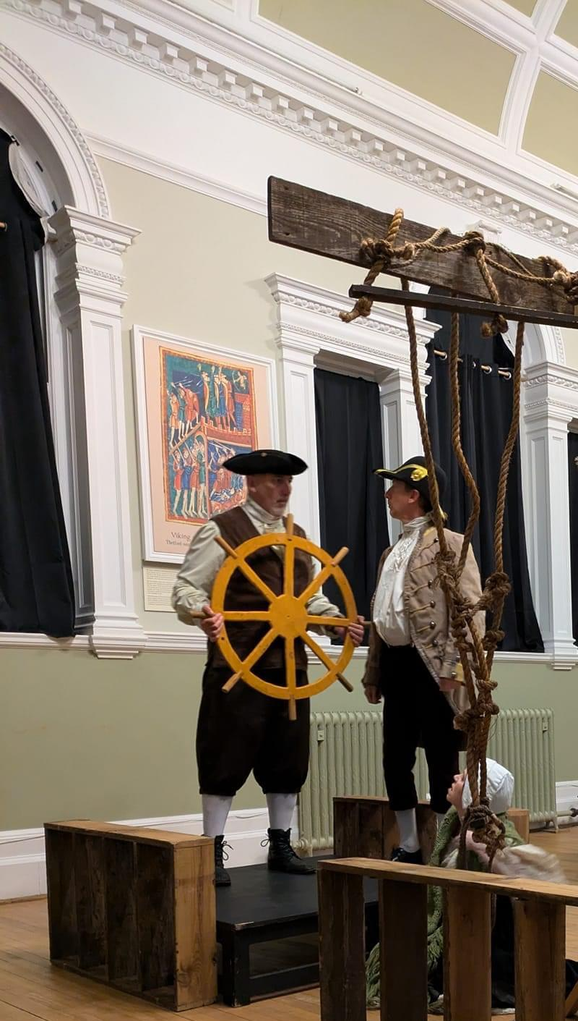**Spotlight:** Admirals Academy Year 6 Visit Holmes and Kable (13/10/23)

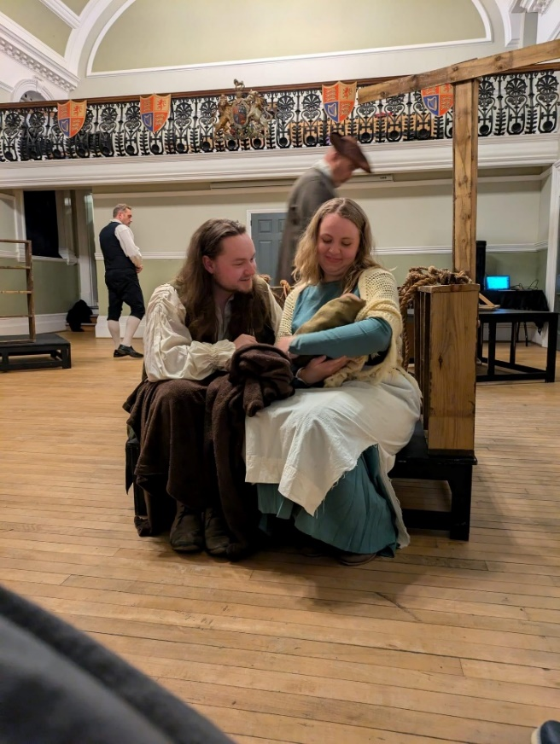

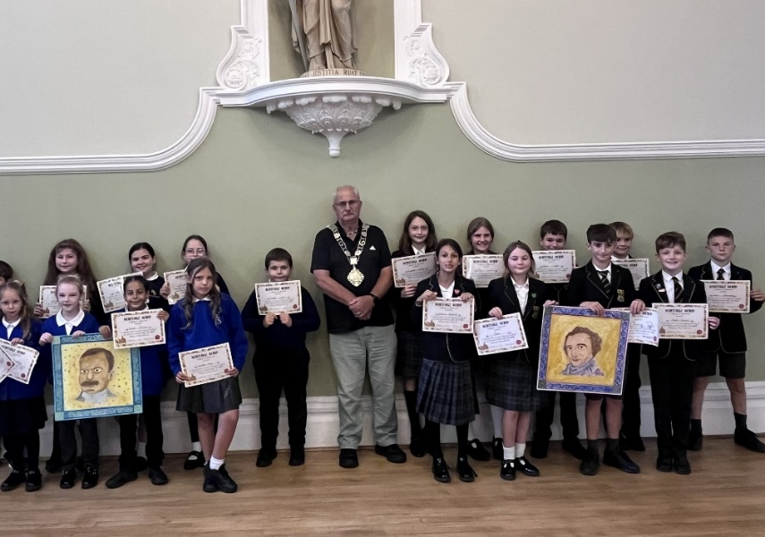**Spotlight:** Mosaic Project Unveiling (11/09/24)

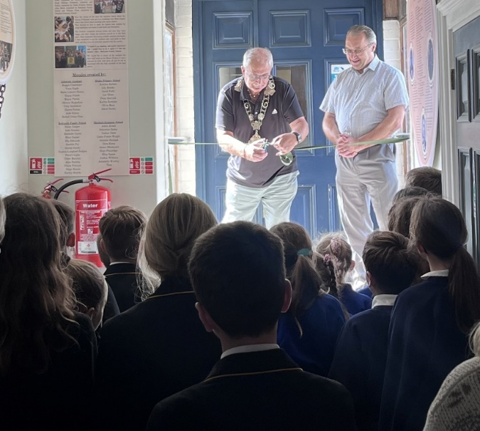

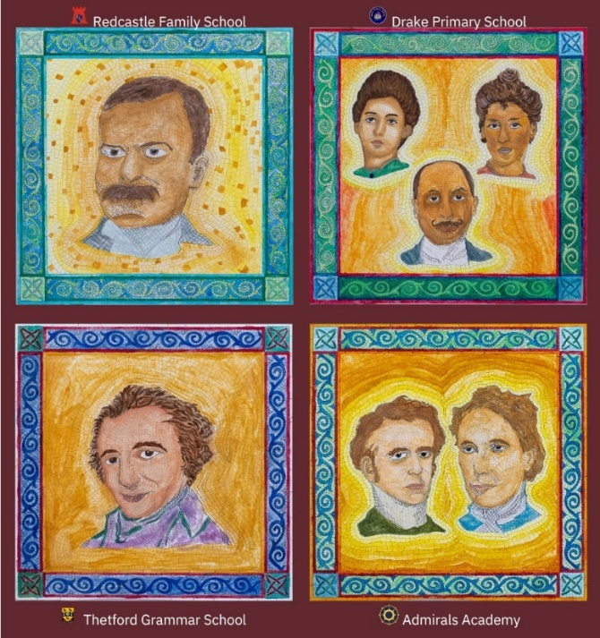

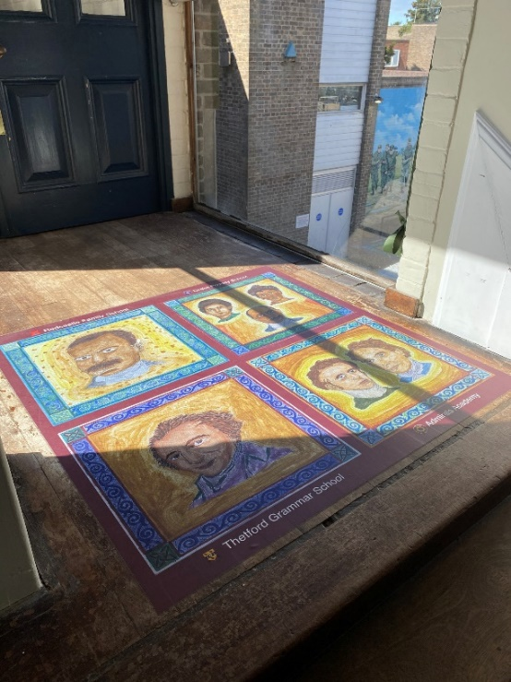





**Agenda Item 403/24**

|  |  |
| --- | --- |
| Report To: | Heritage and Events Committee |
| Date of Meeting: | 13th November 2024 |
| Authorship: | Heritage & Events Manager |
| Subject: | To receive and discuss a proposed programme of events for inclusion in the Committee’s budget for 2025/26. |

**To receive and review a possible programme of Events for the 2025/26 budget year.**

**Mayoral Events**

Current budget 2024/25 totals - £4,800 per annum,

Mayor Making 14th May 2025

Mayor’s Civic Reception 6th June 2025

Mayor’s Church Service & Reception 8th June 2025

Mayor’s Christmas Carol Service 6th December 2025

Mayor’s Christmas Lunch 18th December 2025

**Civic Events**

Current budget 2024/25 totals - £3,600

VE Day 8 May 2025

VJ Day 15 August 2025

Battle of Britain Service & Reception 14 September 2025

Remembrance Concert 8 November 2025

Remembrance Parade & Reception 9 November 2025

**Town Events**

Current budget 2024/25 totals - £12,000

Summer Fun (3 days) 8 August – 10 August 2025

Heritage (incl, Heritage Open Days) 7 September – 14 September 2025

Christmas Lights Switch On Weekend 28 November 2025

The above dates show the standard Mayoral and Civic events – with the inclusion of the 80th Anniversary celebrations for VE & VJ Days. The Committee have expressed a desire to ensure that VE Day is a major celebratory event – the formal commemoration of the VE day will be held in keeping with all the national protocols and programme set Nationally on Thursday 8th May – however it was also suggested that a bigger celebratory event could be held on a day over the weekend, either 10th or 11th May.

The VE Day proposal is to be discussed within agenda item 404/24.

However, what needs to be considered is that in the light of the Heritage & Events team has seen staff cuts to include VE Day & VJ Day into a larger event programme and also deliver 4 town events in 2025, this may be a step too far to staff those events.

The suggestion would be to reduce the Town Events programme for next year to 3 town events – Summer Fun, Heritage & Christmas Lights.

**TTC community and commercial events**

TTC community and commercial events need careful consideration as there can be significant risk and financial losses incurred from such events. Other than the Christmas Light Switch-On, there are currently no community and commercial events planned after 1 January 2025. A new control procedure has now been implemented that no community or commercial events will be planned without the express authority of the Town Clerk. The Town Clerk will assess the risk posed by such events, ensure that these are adequately mitigated and that there is not an overall financial or reputational risk to the Council.

A further factor that the Town Clerk will take into account when authorising these events is staff capacity to undertake these additional events.

The type of events that are subject to this new procedure will include: -

* Easter and Whitsun holiday programmes
* Summer Events
* Friday Live Events
* Car boot and craft markets
* Halloween Activities
* Discos
* Afternoon teas

In this way, the Town Council’s resources will be better used for the benefit of all residents.

As set out in the financial report, partnership events will not be considered in the 2025/26 financial year.

|  |
| --- |
| **Recommendations:**   1. **To discuss and decide the outline programme for 2025/26 for Mayoral, Civic and Town Events.** 2. **To confirm the procedure for TTC Community and Commercial Events.** 3. **To confirm that no partnership events will be considered for the 2025/26 budget year.** |



**Agenda Item 406/24**

|  |  |
| --- | --- |
| Report To: | Heritage and Events Committee |
| Date of Meeting: | 13th November 2024 |
| Authorship: | Heritage & Town Events Manager / VE Day Working Group |
| Subject: | 80th Anniversary of VE and VJ Day in 2025 |

**To review ideas and estimated costs to celebrate the 80th Anniversary of VE and VJ Day in 2025 as proposed in the working group entrusted with this task.**

The VE Day 80 celebrations working have met twice and the Heritage & Events Manager has had further meetings with Lead Councillor Vic Peters in developing the idea that the Committee suggested for the VE Day 80th anniversary celebrations, this event was in addition to the formal event on Thursday 8th May 2025.

It was suggested that the event should take place at a larger outside venue to attract a large audience. It was agreed to look at Melford Terrace & Common, the space used in the past to celebrate Queens Diamond Jubilee event.

Outline costings have been procured and discussions have taken place with businesses and groups that may be able to lend it support and supply their services to enhance the event.

Until the event budget has been agreed it is not possible to secure entertainment for the event as performers are in demand for the event as it will be nationally celebrated therefore at minimum deposits must be made to confirm their attendance – therefore any costs shown below are outline costs and nothing has been contractually secured at this stage.

**Outline event –Melford Terrace - 2pm-6pm**

|  |  |
| --- | --- |
| Performers including headline act | £5,500 |
| Stage – lorry stage to be investigated (V. Peters) | TBC |
| Screen – 1 day hire, install, tech and pack down | £1,995 |
| First Aid – 2 x medics | £400 |
| Security | £691 |
| Waste Services – supply and collection | £450 |
| Toilets - 24 toilets + 2 disabled (suggested for 2000+ people) | £2564 |
| Sound & Technical support – still being investigated. | TBC |

**Income potential**

There could be possible income from Food trucks – hopefully vintage style – to be position on the Norfolk Road side of Melford Terrace – income from pitch fees.

Larry Gray – supply a couple of fairground rides, he usually provides donation however will need power therefore may discussing use of additional generators.

The needs more defined costings however as said this cannot be firmed up until we have made a decision to pursue the large-scale event.

|  |
| --- |
| **Recommendation:**  To provide feedback to the Committee and to discuss the proposals presented. |



**Agenda Item 406/24**

|  |  |
| --- | --- |
| Report To: | Heritage and Events Committee |
| Date of Meeting: | 13th November 2024 |
| Authorship: | Heritage & Events Manager/ Deputy Town Clerk |
| Subject: | Review of venue hire rates, concessions and booking terms & conditions. |

**To review and discuss the proposed changes to the Venue Hire Charges for 2025/26, including concessions. To also confirm proposed changes to the Booking Terms and Conditions for Venues**

1. **Introduction**

As part of the Heritage & Events Committee’s Terms of Reference it is required to annually the Carnegie & Guildhall hire rates and update its booking terms and conditions.

The report provides the current rates as well as some local competitive analysis.

If any charges are made these usually come into effect from 1st April 2025 unless the Committee recommends that these are changed for any new bookings from the 1st January 2025.

We are currently finalising the back end booking functionality of the new Thetford Town Council website which will come into effect in the next few weeks, therefore it may make sense to bring any changes into effect by 1st January 2025 for new bookings.

1. **Current Hire Charges**

At its meeting on 20th September 2023, the then Venues and Markets Committee resolved the following.

|  |  |
| --- | --- |
| *303/23* | *REVIEW OF THE VENUE HIRE FEES 2024/25*  *The Committee reviewed and approved changes to the current venue hire fees for 2024/25.*    *Councillor Carla Barreto proposed, and Councillor Chris Harvey seconded that:*   * *Fees for 2024/25 remain the same as the current fee structure.* * *Additional Service Charge – use of projector and screen to be charged at a cost of £10.00 per session.* * *Kitchen fee £50 when used by external caterers.* * *Sound and Lighting Technician, when required to be provided by The Council at a cost of £150 per event.*     ***RESOLVED: The venue hire fees for 2024/25 be approved.*** |

There have not been any increases to the venue hire since 2021 when the Committee adopted the current hire rates which are outlined below.

It is important to understand concessions, which are a standard £4,16 per hour at all venues. This means that the concession is therefore proportionally higher the lower the venue fee. Organisations that qualify for concessions are: -

* Not for Profit constituted organisations
* Registered charities
* Commercial hirers that pay 3 months in advance.

All hire fees are subject to VAT.

|  |  |  |
| --- | --- | --- |
|  | **Full rate (excluding VAT)** | **Concession Rate (excluding VAT)** |
| **The Carnegie** |  |  |
| Monday to Thursday | £20.83 per hour | £16.67 per hour |
| Friday to Sunday | £25.00 per hour | £20.83 per hour |
|  |  |  |
| **The Large Court** |  |  |
| Monday to Thursday | £16.67 per hour | £12.50 per hour |
| Friday to Sunday | £20.83 per hour | £16.67 per hour |
|  |  |  |
| **The Small Court** |  |  |
| Monday to Thursday | £8.33 per hour | £4.17 per hour |
| Friday to Sunday | £12.50 per hour | £8.33 per hour |
|  |  |  |
| **Guildhall Council Chamber** |  |  |
| Monday to Thursday | £12.50 per hour | £8.33 per hour |
| Friday to Sunday | £16.67 per hour | £12.50 per hour |

1. **Comparison with Competitor Venues**

We compared four venues that are within a local radius of 20 miles and have a similar demographic to Thetford. It is difficult to do comparisons, so we have used like-for-like sized venues as the basis.

|  |  |  |  |
| --- | --- | --- | --- |
|  | **Standard** | **Charity/**  **Community** | **Equipment Charge** |
| **Venue One** |  |  |  |
| Comparable to Carnegie | £39 per hour | £21 per hour | Yes |
| Comparable to Guildhall Large Court | £27 per hour | £15 per hour | Yes |
| **Venue Two** |  |  |  |
| Comparable to Guildhall Large Court | £22.08 per hour | £15.42 per hour | No |
| **Venue Three** | **Day Time** | **Evening & Weekends** | **Equipment Charge** |
| Comparable to Carnegie | £17.75 per hour | £20.83 per hour | No |
| **Venue Four** |  |  |  |
| Comparable to Council Chamber | £12.50 per hour |  | No |

1. **Officers’ Recommendations**

The fees proposed (excluding VAT) are as follows:

|  |  |  |
| --- | --- | --- |
|  | **Full rate (excluding VAT)** | **Concession Rate (excluding VAT)** |
| **The Carnegie** |  |  |
| Monday to Thursday | £25.00 per hour | £20.00 per hour |
| Friday to Sunday | £30.00 per hour | £25.00 per hour |
|  |  |  |
| **The Large Court** |  |  |
| Monday to Thursday | £20.00 per hour | £15.00 per hour |
| Friday to Sunday | £25.00 per hour | £20.00 per hour |
|  |  |  |
| **The Small Court** |  |  |
| Monday to Thursday | £15.00 per hour | £12.50 per hour |
| Friday to Sunday | £20.00 per hour | £15.00 per hour |
|  |  |  |
| **Guildhall Council Chamber** |  |  |
| Monday to Thursday | £15.00 per hour | £12.50 per hour |
| Friday to Sunday | £20.00 per hour | £15.00 per hour |

Should there be a function in the Large Court where the Council provides a bar and/or catering service, then the Small Court will not be charged as a venue cost.

The average hourly rate for a monthly paid staff member who will typically act as a caretaker is £15,82. Taking that into account, should the Guildhall Council Chamber or the Small Court be hired out after-hours, then hiring out the venue will incur a slight loss on the Monday to Thursday pricing hiring slot (if the caretaking is after hours).

To prevent a larger loss being incurred, it is recommended that a concession rate cannot be claimed after 5.00pm for any booking other than in the Carnegie.

It is also recommended that only charities and constituted community groups are eligible for a concession. No other individual or organisation is eligible for a concession.

1. **Booking Terms and Conditions**

Once the Committee has considered the proposals around the new charges and concessions, then the Booking Terms and Conditions can be updated and presented to the Committee for approval.

|  |
| --- |
| **Recommendations:**   1. The new proposed hire charges be adopted by the Committee. 2. Concessions be limited to registered charities or constituted community groups. 3. Concessions cannot be granted for any venue booking that starts after 5.00pm in any of the venues other than in the Carnegie. 4. That all future venue costs increase by 5% on 1 April of each year unless the Committee decides otherwise by resolution. 5. The Booking Terms and Conditions be tabled at the next Heritage and Events Committee meeting to incorporate the decisions made in this agenda item. |



**Agenda Item 407/24**

|  |  |
| --- | --- |
| Report To: | Heritage & Events Committee |
| Date of Meeting: | 13th November 2024 |
| Authorship: | Deputy Heritage and Events Manager/ Town Clerk |
| Subject: | Guildhall Community Groups |

**To receive a report on the continued use of the Guildhall facilities for continuation of In-house Community Groups as well as the use of Council staff time.**

1. **Introduction**

Thetford Town Council (TTC) currently hosts several in-house community groups, including The Guildhall Choir, The Guildhall Craft Group, The Guildhall Writers Group, and Thetford Strings. These groups (other than Thetford Strings) were initially established under the Guildhall Heritage Project, funded by the Heritage Lottery Fund, to enhance community engagement in arts and culture. The Thetford Strings was established earlier in the 2024 year.

The Guildhall Heritage Project was concluded in October 2023, the Council must now consider if it remains appropriate to continue providing facilities to these groups free of charge.

This report outlines the groups' activities, operational considerations, and associated costs to assist in this decision.

1. **Group Details and Associated Costs**

|  |  |  |  |  |  |  |
| --- | --- | --- | --- | --- | --- | --- |
| Group | Frequency | Room Hire Costs | Staff Costs | Tea/Coffee | Monthly Total | Yearly Total Costs |
| Craft Group | Weekly (Daytime) | £0 | £0 | £48.00 | £48.00 | £ 576.00 |
| Writers Group | Monthly (Evening) | £25.00 | £40.00 | £12.00 | £77.00 | £ 924.00 |
| Choir | Twice Monthly (Evenings) | £40.00 | £80.00 | £0 | £120.00 | £1,440.00 |
| Thetford Strings | Twice Monthly (Evenings) | £40.00 | £80.00 | £0 | £120.00 | £1,170.00 |
| Total Yearly Costs |  |  |  |  |  | £4,110.00 |

1. **Utilisation and Participation**

The Guildhall Craft Group meets during the day in an underutilised hallway, incurring no room hire or staff costs in theory as they operate during the day when the office has staff available. The only expense is for tea and coffee, totalling £48.00 monthly.

Only 50-60 people in total currently participate in these free groups, and it is unknown if all are Thetford residents or if some reside outside of the Thetford area. There is also an element of double counting as the same individuals could be participating in more than one group.

1. **Contribution to Council and External Activities**

While these groups support TTC events by offering performances and content, they also contribute their services externally. For instance:

* The Guildhall Writers Group writes content for other magazines beyond Council projects.
* The Guildhall Choir and Thetford Strings occasionally perform at non-council events, assisting other organisations within and outside Thetford.
* These contributions to external organizations mean that while the groups are valuable to TTC’s objectives, their reach and services extend beyond TTC events.

1. **Justification for Use of Town Council Facilities**

These community groups were originally established as part of TTC’s commitment to arts, heritage, and culture, aligning with the goals of the Guildhall Heritage Project. They have provided valuable contributions to community engagement and TTC events, many small towns rarely host similar programs, but these groups have increased community outreach and offered a legacy of the Guildhall Heritage Project.

1. **Operational Considerations**

Most groups, apart from the Craft Group, meet during the evening, requiring staff presence outside of regular hours. Sometimes this is offset by the staff member being utilised for private hires, but this is not a permanent offset. These evening meetings contribute to additional staff costs and utility expenses (lighting, heating).

Please note that although the groups do not generate direct revenue, they support Council events (for example Mayor Making and D-Day), contributing to cultural and heritage programming without external performance costs.

1. **Conclusion**

The community groups hosted by TTC provide cultural and social benefits, engaging residents and enhancing TTC’s event offerings. However, now that the Heritage Project funding has ended, the Council must evaluate whether continuing to offer free access to

Council facilities for these groups is financially viable.

|  |
| --- |
| **Recommendations**   1. To consider whether to continue the free use of Council premises for the groups. 2. Consider whether the night groups should continue twice weekly or move to monthly or a lesser frequency to save on costs. 3. Should the groups continue, the Heritage and Events team will produce a six-month report to this Committee on the activities that they have achieved. 4. Should the groups continue that the groups are advertised to try and extend their reach to other members of the community. 5. All new free groups are to be agreed upon by resolution of the Heritage and Events Committee before being implemented. |



**Agenda Item 408/24**

|  |  |
| --- | --- |
| Report To: | Heritage & Events Committee |
| Date of Meeting: | 13th November 2024 |
| Authorship: | Deputy Town Clerk |
| Subject: | Progress on Actions from Previous Meetings |

To review and update the action points brought forward from the previous Heritage and Events meeting as well as those that have been reported.

See the following pages.

|  |
| --- |
| **Recommendation:**  That the status of the Action Plans be discussed and updated. |

**Actions carried forward from previous meetings**



**Actions carried forward from previous meetings**



**Actions reported as completed at previous meetings**

