|  |
| --- |
| **‘Extraordinary’ Full Council Agenda Pack**  **12 November 2024** |

Thetford Town Council, The Carnegie, Cage Lane, Thetford, IP24 2DS

Tel: 01842 754247

**THETFORD TOWN COUNCIL**

**‘EXTRAORDINARY’ FULL COUNCIL**

Date: **Tuesday 12th November 2024** Time**:** **7:00 pm**

Place: **Guildhall Large Court, The Guildhall, Market Place, IP24 2DT**

**Members are hereby summoned to attend the above meeting to transact the following business. Members are respectfully reminded that each item on the agenda should be carefully examined.**

**COUNCILLORS**

C. Harvey (Mayor), C. Barreto (Deputy Mayor), A. Blackbourn, D. Blackbourn, M. Brindle, I. Evans, D. Jefferson, T. Jermy, T. Land, M. MacDonald, H. McCambridge, A. Mitchell, V. Peters, V. Ross-Smith, M. Stirrup, S. Terry, R. Wood, S. Wright.

Pp 

**Town Clerk**

7th November 2024

**AGENDA**

|  |  |
| --- | --- |
| **384/24** | **Apologies for Absence**   To receiveand approve apologies for absence. |
| **385/24** | **Full Council Minutes**  To confirm the minutes of the Full Council meeting held on 29 October 2024 as a true record and be signed/initialled by the Mayor.  Decision required: To agree the minutes of the last meeting.  Lead: Mayor. |
| **386/24** | **Declaration of any Disclosable Pecuniary Interests**  To receive any additional interest not already registered. |
| **387/24** | **Community Engagement**  To discuss and agree on any consultation or media release required.  Decision required: To approve any media release that is required and to specify in what format the media release should take (social media posts and/or press releases).  Decision required: Media releases that are required by Council.  Lead: The Mayor. |

|  |  |
| --- | --- |
| **388/24** | **Parish Partnership Bid – County Council**  To receive and consider a report regarding a Parish Partnership Funding Bid to Norfolk County Council for a new Bus Shelter on Norwich Road.  Decision required: Whether to put the Bid for a new bus shelter forward to the Parish Partnership Fund.  Lead: Deputy Town Clerk. |
| **389/24** | **Flag Flying Policy**  To receive and consider implementing a new Flag Flying Policy as agreed by the Heritage and Events Committee on the 18 September 2024.  Decision required: To agree to implement the Policy  Lead: The Mayor. |
| **390/24** | **External Audit Report**  To receive the External Audit Report on the limited assurance review undertaken on the Annual Governance and Accountability Return and to note that there are no further actions to take.  Decision required: To note the External Audit Report.  Lead: The Deputy Town Clerk. |
| **391/24** | **Outside Bodies Appointment**  To receive the resignation of Councillor Chris Harvey as a Council representative on the Charles Burrell Centre Board. To call for nominations for a Councillor to now represent the Council on the Charles Burrell Centre Board.  Decision required: To nominate a Councillor to the Board of the Charles Burrell Centre.  Lead: The Mayor. |
| **392/24** | **Action Points**  To review and discuss the action points carried forward from the previous meetings of the Full Council.  Decision required: To request that the action points be updated based on the review.  Leads: Chair and Deputy Town Clerk. |
| **393/24** | **Exclusion of Press and Public**  To consider resolving that, pursuant to the Public Bodies (Admission to Meetings) Act 1960, the press and public be excluded for any remaining items of business on the grounds that publicity would be prejudicial to the public interest by reason of the confidential nature of the business to be discussed.  Decision required: Whether or not to exclude the press and public.  Lead: The Mayor. |
| **394/24** | **Internet and IT Infrastructure**  To receive and consider a report regarding an upgrade of the Internet and IT infrastructure at the Carnegie and Guildhall complex.  Decision required: To agree to the proposals for an upgrade to the Internet and IT Infrastructure.  Lead: Deputy Town Clerk. |

|  |  |
| --- | --- |
| **395/24** | **Exclusion of a Member of the Public from Attending Council Meetings**  To consider whether to exclude a member of the public from future Council meetings as set out in the Council’s Public Participation Policy.  Decision required: To exclude a member of the public in terms of the policy.  Lead: Deputy Town Clerk. |

**A recording of the meeting can also be viewed on**

[**https://bit.ly/ttceventsyoutube**](https://bit.ly/ttceventsyoutube) **usually within 5 working days after the meeting has been held.**

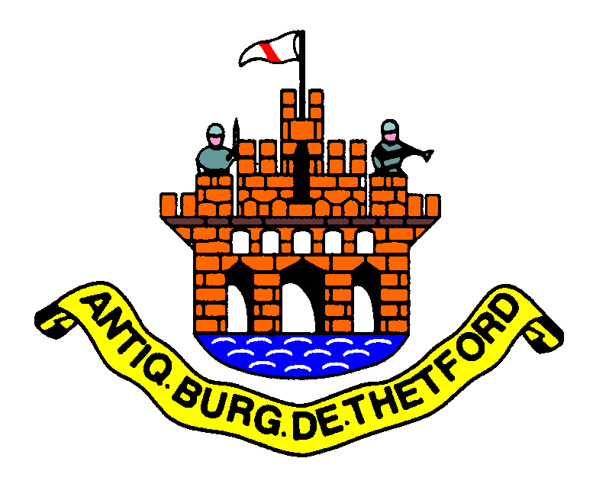

**DRAFT**

**Agenda Item: 385/24**

|  |  |
| --- | --- |
| Report To: | ‘Extraordinary’ Full Council |
| Date of Meeting: | 12th November 2024 |
| Authorship: | Town Clerk & Deputy Town Clerk |
| Subject: | Confirm the Minutes |

To confirm the minutes of the Full Council meeting held on 29th October 2024 as a true record and be signed/initialled by the Mayor.

# Full Council

Minutes

29 October 2024

Present: Councillors: C. Harvey (Mayor)

C. Barreto (Deputy Mayor)

A. Blackbourn

D. Blackbourn

M. Brindle

T. Land

M. MacDonald

A. Mitchell

V. Peters

M. Stirrup

S. Terry

R. Wood

S. Wright

Officers: S. Wright (Town Clerk)

A. Yorke (Deputy Town Clerk)

K. Robinson (Committee Clerk)

Members of Public: There were 40+ members of the public present.

Councillors, Council staff, and members of the public observed a minute of silence in memory of Colin Burnett, a previous Town Councillor, who recently passed away. Colin served as a Councillor from May 2015 until November 2021.

**357/24 Apologies for Absence**

Apologies were received from Councillors I. Evans, D. Jefferson, T. Jermy, H. McCambridge and V. Ross-Smith.

**358/24** **Full Council Committee Minutes**

Council agreed that the minutes of the Extraordinary Full Council meeting held on 8 October 2024 were a true record and signed by the Chairman.

**359/24** **Declarations of Any Disclosable Pecuniary Interests**

There were none.

**360/24** **Public Participation**

There were 40+ members of the public in attendance. During the public participation session, a local artist requested the return of a painting that was currently in the Council’s possession, as they no longer wished for it to remain in the Council's possession. Members of the public also expressed views on climate change, with some asserting that there is no climate emergency, and that they believed that there is insufficient evidence to support such a declaration.

During this time, some members of the public were extremely disruptive and unruly, disregarding meeting protocols and leading to repeated warnings about their behaviour.

**19:16** The Chairman formally suspended the meeting due to the disruptions from members of the public attending the meeting. A formal warning letter was subsequently issued to one individual regarding their conduct.

**19:25** The meeting was reconvened.

**361/24** **Mayor’s Report**

The Mayor provided an overview of the report, highlighting key findings and recommendations that were included in the Agenda Pack.

**362/24** **Town Council Representatives on Other Bodies/District and County Councillors**

Councillor V. Peters informed members of an upcoming meeting with the Royal British Legion to discuss arrangements for the Remembrance Parade scheduled for 10th November 2024.

Councillor M. MacDonald reported on behalf of the Safer Thetford Action Group (STAG) and advised that the next meeting is scheduled for 18th November 2024.

Councillor S. Wright shared that he had recently attended the annual Cluniac Conference in Northampton. Additionally, he has been in contact with a representative from English Heritage in Bedford, who possesses Thetford Priory assets that could potentially be returned and displayed at the Priory site as part of a future project within the Heritage Master Plan.

Councillor T. Land reported on his recent attendance at meetings with Anglia in Bloom and Breckland Council, which included discussions on fly-tipping.

Councillor C. Barreto informed members of her attendance at the AGM for the Thetford Music Project. She also highlighted the upcoming end-of-year concert, which will be held at The Carnegie on 8th December 2024.

**363/24** **Town Clerk Report**

Members noted the contents of the Town Clerks report.

Councillor T. Land thanked the Town Clerk for her report.

**364/24** **Update on Standing Orders**

Councillors received and discussed the revised standing orders. It was

**RESOLVED:** To approve the updates to Standing Orders.

Proposed by Councillor T. Land and seconded by Councillor M. Stirrup.

**Action:** Town Clerk to arrange to put the Standing Orders onto the website; immediately.

**365/24** **Car Parking Charges**

Councillors discussed the report regarding the proposed car parking charges,

It was

**RESOLVED:** That Thetford Town Council formally opposes the introduction of car parking charges in Thetford and calls for further discussions with Breckland District Council to explore alternative solutions that would avoid the financial burden on residents while maintaining parking services.

That Thetford Town Council engages with local businesses and residents to gather feedback during Breckland District Council’s public consultation, ensuring that the concerns of Thetford’s community are fully represented.

**Action**: Town Clerk to write a letter to Breckland and Councillors to sign; immediately.

Proposed by Councillor M. Stirrup and seconded by Councillor S. Wright.

During the discussion on car parking, the meeting was repeatedly disrupted by a series of interruptions from members of the public. These disruptions included individuals shouting, phone alarms sounding, and attendees standing to voice their opinions without invitation. The interruptions were persistent and created a challenging environment for productive discussion. Despite multiple reminders about meeting decorum, three members of the public received formal verbal warnings from the Chairman regarding their behaviour.

**366/24** **Parish Partnership Bid**

As Councillors began discussing the future Parish Partnership Bid, they were repeatedly interrupted by members of the public. The level of disruption escalated, with a continuous stream of interruptions and a verbal onslaught directed toward Council members. Due to the intensity of these disruptions, the Chairman ultimately called for a vote, and it was agreed to conclude the meeting early.

**7.51pm** Due to persistent and disruptive behaviour from members of the public, Councillors were unable to complete the scheduled business of the Council. As a result, the Chairman made the decision to conclude the meeting early to maintain order

Chairman: C. Harvey

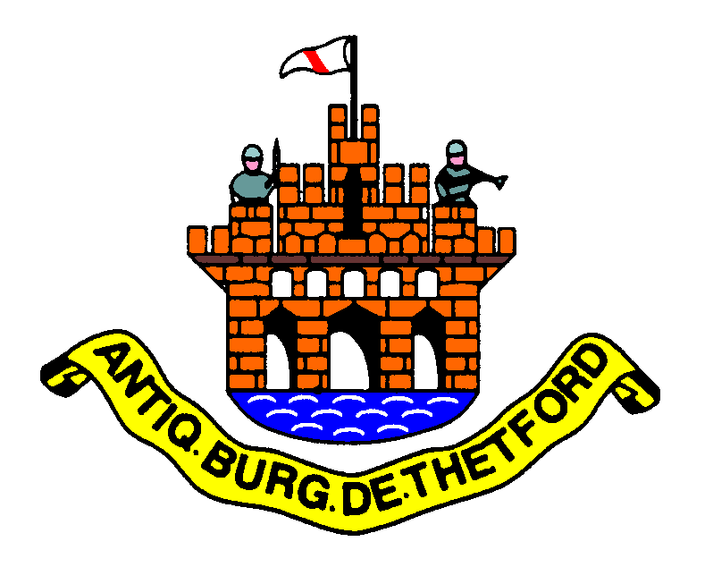

Item Number:

**388/24**

|  |  |
| --- | --- |
| Report To: | ‘Extraordinary’ Full Council |
| Date of Meeting: | 12th November 2024 |
| Authorship: | Town Clerk |
| Subject: | Parish Partnership Bid |

**To consider a Parish Partnership Bid and to decide whether to submit the bid to Norfolk County Council.**

1. **Introduction**

This report outlines the proposal to install a new bus shelter at the Norwich Road/Churchill Road junction as part of our Parish Partnership bid. The shelter will serve residents using the Thetford Bee bus line, which offers an affordable £2 fare for travel to Norwich. The bid funding will come from the Parish Partnership Fund, with additional support from the Climate Initiative Fund, (See Appendix A).

1. **Objectives**

* **Shelter from Weather:**

The installation of the bus shelter will provide a safe, sheltered place for residents to wait in comfort, particularly during inclement weather. This will improve the overall passenger experience and increase the likelihood of residents choosing public transport over private cars.

* **Cost-Effective Transport:**

The Thetford Bee bus line offers an affordable £2 fare, providing residents with a low-cost travel option to Norwich, the main city in the area. This is crucial as the cost of living rises, making affordable transport more important than ever.

* **Environmental Benefits:**

By encouraging greater use of public transport, this initiative will help reduce traffic congestion and lower carbon emissions, contributing to our town’s environmental sustainability goals. Fewer cars on the road mean less pollution and a greener future for Thetford.

1. **Cost**

The total Project Cost is £25,860, which includes purchasing the bus shelter and its installation.

1. **Funding**

The Council will apply for funding of £12,390 via the Norfolk County Council Parish Partnership Fund. This fund is designed to support local highway improvements in partnership with Town and Parish Councils. Under the scheme, Norfolk County Council will cover up to 50% of the project costs, with a maximum contribution of £25,000 per bid.

The Parish Partnership Fund aims to support projects that directly benefit local communities, such as installing new bus shelters, improving public rights of way, and enhancing pedestrian safety.

The fund particularly encourages first-time bids and projects that align with local transport plan objectives, such as reducing traffic and promoting sustainable transport options.

The remaining cost of £12,390 will be funded through the Climate Initiative Fund, aligning with the Council’s commitment to supporting environmentally friendly projects.

1. **Conclusion**

The proposed bus shelter will provide significant benefits to the community, from improved comfort for bus passengers to help reducing traffic and environmental impacts. This project supports our broader sustainability objectives and offers a practical solution to enhance the local public transport experience (see Appendix A for the full Parish Partnership Bid Application).

|  |
| --- |
| **Officer Recommendations:**   1. Approve the Parish Partnership Bid for the Bus Shelter to be sent to the County Council for consideration. 2. Approve the costs to be funded from the Climate Initiative Fund. |



**Agenda Item: 389/24**

|  |  |
| --- | --- |
| Report To: | ‘Extraordinary’ Full Council |
| Date of Meeting: | 12th November 2024 |
| Authorship: | Councillor Doug Jefferson |
| Subject: | Flag Flying Policy |

**To receive and consider implementing a new Flag Flying Policy as agreed by the Heritage and Events Committee on the 18th September 2024.**

**Thetford Town Council**

**Flag Flying Policy**

**Last Reviewed: Adopted at October 2024 – Full Council**

**Next Review: September 2028**

1. **Introduction**

This policy sets out Thetford Town Council’s policy for flag flying.

Flags are traditionally flown by the Town Council for a variety of reasons; to show allegiance, support, or respect or to celebrate. The Town Council will always be sensitive to the views of all sectors of its community and will never use flags for political purposes.

As from Summer 2021 government guidance states that UK Government building flagpoles should not remain empty – the default should be flying the Union Flag if no other flag is being flown. This guidance is aimed at UK Government buildings; however, they encourage local authorities and other local organisations to follow suit where they wish to fly flags.

This policy can be amended at any time the Heritage and Events Committee.

1. **Information**

Thetford Town Council owns 6 flagpoles, these are situated at:

* Guildhall [1 flag pole].
* Kings House [5 flag poles]

The Union Flag will be flown at Guildhall all year round unless another flag is being flown.

Other Flags will be flown from only the flagpole at the Guildhall on recognised days and will be flown for one day unless agreed otherwise.

Officers will raise the appropriate flag at Guildhall at 9:00am on a recognised flag flying day. The Flag will be flown until the following morning unless specified otherwise.

When a flag flying day falls on a weekend the flag will be raised at 4:00pm on a Friday and lowered at 8:00am on a Monday.

The Union Flag will be flown at the central flagpole at Kings House all year round. The additional poles at Kings House will fly appropriate flags if owned according to the timings as per 4.4 below.

1. **Flying the Union Flag at Half Mast**[[1]](https://ukc-word-edit.officeapps.live.com/we/wordeditorframe.aspx?ui=en-US&rs=en-GB&wopisrc=https%3A%2F%2Fthetfordtc.sharepoint.com%2Fsites%2FMain%2F_vti_bin%2Fwopi.ashx%2Ffiles%2Fe1481e2ae63b42b4b9eb0df7c8410b30&wdenableroaming=1&mscc=1&hid=99944DA1-809C-9000-BB37-33CBA4E92359.0&uih=sharepointcom&wdlcid=en-US&jsapi=1&jsapiver=v2&corrid=ab10b31c-c399-e7ed-5f97-401e4a749bce&usid=ab10b31c-c399-e7ed-5f97-401e4a749bce&newsession=1&sftc=1&uihit=docaspx&muv=1&cac=1&sams=1&mtf=1&sfp=1&sdp=1&hch=1&hwfh=1&dchat=1&sc=%7B%22pmo%22%3A%22https%3A%2F%2Fthetfordtc.sharepoint.com%22%2C%22pmshare%22%3Atrue%7D&ctp=LeastProtected&rct=Normal&wdorigin=ItemsView&wdhostclicktime=1725622436194&instantedit=1&wopicomplete=1&wdredirectionreason=Unified_SingleFlush#_ftn1)

According to the College of Arms website, the Union Flag shall be flown at half-mast in the following circumstances:

* From the announcement of the death of the sovereign until the funeral.
* On the death of a member or near relative of the Royal Family or the funeral of members of the Royal Family.
* The funerals of Prime Ministers and ex-Prime Ministers of the United Kingdom; and
* Any other occasions as commanded.

The Department of Culture, Media and Sport will inform Government departments of any other occasions when His Majesty has given a special command. The College of Arms will publish details of half-masting instructions for the information of local and national government and any other interested bodies or individuals.

Local government bodies are permitted to fly the Union Flag at half mast to mark local as well as national commemorations or losses, including the death of present councillors or past Mayors. In this case flags would be flown at half-mast for one day.

These occasions can include:

* On the death/funeral of a serving officer in the Armed Forces from the town.
* On Holocaust Day in January.
* On the death/funeral of a serving Town Councillor, local Unitary Councillor, or local Member of Parliament; or
* At the discretion of the Chair (or Vice-Chair of the Heritage and Events Committee if the chair is away), to commemorate local civic and community dignitaries who have recently passed away.

1. **Other Flags**

The list below outlines occasions when other flags can be flown from the Guildhall. This list will be reviewed at the first meeting of the Heritage and Events committee of the Mayoral year (in June) and can be amended if the committee pass the motion:

* On the second Monday in March the Council will fly the Commonwealth Flag in recognition of Commonwealth Day.
* On St George’s Day, 23 April, the Flag of St George may be flown.
* On International Day Against Homophobia, Transphobia, and Biphobia, May 17th, the Council will fly the Pride Rainbow flag in recognition of those who have different sexual identities.
* On Armed Forces Day, June 29th, the council will fly the Armed Forces Day Flag in recognition of Armed Forces Day.
* On Norfolk Day, 27th June, the council will fly the Norfolk Flag in recognition of Norfolk Day.

As well as the above noted days, the Flag of St George may be flown to celebrate or support sporting events of significance of an England Team. This shall be at the discretion of the Chair (or Vice-Chair of the Heritage and Events Committee if the chair is away).

If a flag is not currently owned by Thetford Town Council, then this must be discussed by the Heritage and Events committee.

The list below outlines occasions when other flags can be flown from the additional flagpoles at Kings House. Whilst the main flagpole should continue to fly the Union Flag, the additional flagpoles may be used to fly the following flags. This list will be reviewed at the first meeting of the Heritage and Events Committee of the Mayoral year (in June) and can be amended if the committee pass the motion:

* From the Monday before International Holocaust Memorial Day 27 January to the Monday after, the Council will fly the Holocaust Memorial Day flag in recognition of Holocaust Memorial Day.
* On the second Monday in March the Council will fly the Commonwealth Flag in recognition of Commonwealth Day.
* From the Monday before St George’s Day, 23 April, till the Monday after, the Flag of St George may be flown.
* On International Day Against Homophobia, Transphobia, and Biphobia, May 17th, the Council will fly the Pride Rainbow flag in recognition of those who have different sexual identities.
* During Pride month, 1-30 June the Pride Rainbow flag in recognition of those who have different sexual identities.
* From the Monday before Armed Forces day, June 29th, until the Monday after, the council will fly Armed Forces Day Flag in recognition of Armed Forces Day.
* From the Monday before Norfolk Day, 27th June, to the Monday after, the council will fly the Norfolk Flag in recognition of Norfolk Day.

From the 31st October until the Monday after Remembrance Sunday, or the 12th November (whichever is later) the “Lest We Forget” flag will be flown.

As well as the above-noted days, the Flag of St George may be flown to celebrate or support sporting events of significance of an England Team. This shall be at the discretion of the Chair (or Vice-Chair of the Heritage and Events Committee if the chair is away).

If a flag is not currently owned by Thetford Town Council, then this must be discussed by the Heritage and Events Committee. If the purchase is approved this flag can be flown as per 4.7

1. **How should the Union Flag be flown?**

The flag must be flown the correct way up, www.flaginstitute.org/wp/ see for further details. The correct way up for the Union Flag when flying is with the broader diagonal white stripe at the top left-hand side of the flag nearest the flagpole.

Please Note: Half-mast means the flag is flown two-thirds of the way up the flagpole with at least the height of the flag between the top of the flag and the top of the flagpole. (The Flag Institutes Flag Flying Protocol).



**Agenda Item: 390/24**

|  |  |
| --- | --- |
| Report To: | ‘Extraordinary’ Full Council |
| Date of Meeting: | 12th November 2024 |
| Authorship: | Deputy Town Clerk |
| Subject: | External Audit Report |

**Background**

Thetford Town Council is subject to a limited assurance external audit.  The audit covers the Annual Governance and Accountability Return (AGAR) and other documentation (variance reports and templated reconciliations) that we have to submit.

The Town Council is also subject to an independent internal audit, whose report was tabled at a Corporate Services meeting held on 18 July 2024.

It is a governance requirement that the External Audit Report is brought to the attention of the Council.

**External Audit Report**

The external audit report is attached Annexure A.

There are no matters noted (this is the second consecutive year that there are no matters to note).

|  |
| --- |
| **Officer’s Recommendation:**  Full Council to note the report. |

**Annexure A**



**Agenda Item 392/24**

|  |  |
| --- | --- |
| Report To: | ‘Extraordinary’ Full Council |
| Date of Meeting: | 12th November 2024 |
| Authorship: | Town Clerk and Deputy Town Clerk |
| Subject: | Progress on actions from previous meetings |

**To review the action points carried forward from previous meetings as well as those items that have been completed during the current Mayoral Year.**



